Test case -1: User did not play the game. The program will display a message says: You did not play the game.

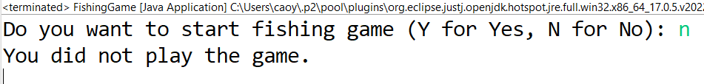

Test case-2: User plays the game one time. The program rolls the die and get random face number 2, which is within the range of 1 to 6 as expected. And ITEMS[2-1]= ITEMS[1] is “big fish”, and SCORES[1] is 50, both item and score outputs are correct. The program will display summary statistics as required after user finish playing the game. The summary statistics outputs are correct. Item_list and score_list stored game results properly and the game results are displayed correctly.

Test case-3: user played the game multiple times. Double checked all outputs are correct and displayed properly in console.

